**電通二乙微處理器實驗 實驗結報**

|  |  |  |  |
| --- | --- | --- | --- |
| **實驗名稱** | **Lab07-LCD顯示器** | | |
| **組別** |  | **組員** | **03053622** |

1. **實驗目的**

**使用 Arduino LCD程式庫,於16x2LCD顯示器上特殊文字?**

**(1) Arduino與LCD如何接線?**

**(2)如何使用 LCD Liberary?**

**(3) 如何清除螢幕?**

**(4)如何顯示文字?**

1. **實驗步驟: Arduino顯示自己的學號與英文姓名**

**電路圖:**

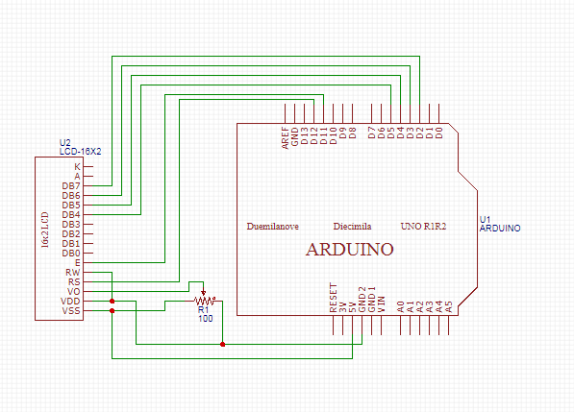

|  |
| --- |
| **程式碼:**  **#include <LiquidCrystal.h> // include the library code**  **LiquidCrystal lcd(12, 11, 5, 4, 3, 2); // initialize interface pins**  **void setup()**  **{**  **lcd.begin(20, 2); // set up the LCD's number of columns and rows:**  **lcd.print("04053124");**  **lcd.print("Lin"); // Print a message to the LCD.**  **}**  **void loop()**  **{**  **// set the cursor to column 0, line 1**  **// (note: line 1 is the second row, since counting begins with 0):**  **lcd.setCursor(0, 1);**  **lcd.print(millis()/1000); // print the number of seconds since reset:**  **}** |

**實驗結果及分析**

**實驗成功**

1. **實驗步驟: 使用PC串列輸入,所有PC輸入之文字皆顯示在LCD螢幕上**

**電路圖:**



|  |
| --- |
| **程式碼:**  **#include <LiquidCrystal.h> // include the library code**  **LiquidCrystal lcd(12, 11, 5, 4, 3, 2); // initialize interface pins**  **void setup()**  **{**  **lcd.begin(20, 2); // set up the LCD's number of columns and rows:**  **Serial.begin(9600);**  **}**  **void loop()**  **{**  **// when characters arrive over the serial port...**  **if (Serial.available()) {**  **// wait a bit for the entire message to arrive**  **delay(100);**  **// clear the screen**  **lcd.clear();**  **// read all the available characters**  **while (Serial.available() > 0) {**  **// display each character to the LCD**  **lcd.write(Serial.read());**  **}**  **}**  **}** |

**實驗結果及分析**

**實驗成功**

1. **心得討論**

**這次實驗接線的部分卡了，幸好最後有做出來。**